***FIRST®* Robotics Competition – Branding Guidelines**

**Below are guidelines specific to team usage of the Comcast NBCUniversal logo and brand for the 2016-2017 *FIRST®* Robotics Competition season. If you have any questions, file requests, or would like to have proofs reviewed, please contact Christine Jereb at** [**Christine_jereb@comcast.com**](mailto:Christine_jereb@comcast.com)**.**

**Proper Logo Usage**

*FIRST* team sponsor recognition materials, such as websites, t-shirts or flyers, should include one of the two approved logos below. The multi-line stacked logo is the preferred logo; however, the single line horizontal logo can be used if it fits better in the available space. Do not crowd the logo or place it too close to other logos or graphics. Try to maintain at least one peacock width of space around the logo.

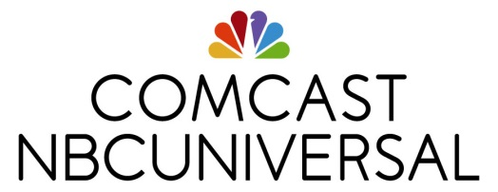



Below are guidelines outlining the various available file and color types and their preferred usage:

**File Types:**

JPG: Use for web or screen applications; has a solid white background.   
PNG: Use for web or screen applications; has a transparent background and can be placed on color (non-white) backgrounds.

EPS: Use for print; requires a design program to view and use.

**Color Variations:**

Full color (lettering in black, colored peacock): Preferred file format, only to be used on white and light grey backgrounds.  
Black (lettering and peacock in black): Use on white or light grey backgrounds for black & white publications.  
White (lettering and peacock in white): Use on Xfinity red or other colored backgrounds.  
White color (lettering in white, colored peacock with white border): Use on black or Comcast blue backgrounds.

**All files are available for download at:** [**https://comcast.box.com/s/tmtzktj97yt3nq2l1ey6**](https://comcast.box.com/s/tmtzktj97yt3nq2l1ey6)

**Proper Text Treatment**

The company name should be written and spoken as:   
**Comcast NBCUniversal**

Do not add a slash, hyphen or other punctuation to the company name. When referencing our company in copy, please use the below example:

“Comcast NBCUniversal ***is*** proud to support…” (usage should be singular)

**These logos, or other variations, should NEVER be used on *FIRST* materials:**



